**WEEK_2**

**PL/SQL Control Structures & Stored Procedures**

**Exercise 1: Control Structures**

**Scenario 1:** The bank wants to apply a discount to loan interest rates for customers above 60 years old.

* + **Question:** Write a PL/SQL block that loops through all customers, checks their age, and if they are above 60, apply a 1% discount to their current loan interest rates.

Program: CREATE TABLE CUSTOMERS (

CUSTOMER_ID NUMBER PRIMARY KEY,

AGE NUMBER,

LOAN_INTEREST NUMBER

);

SELECT table_name FROM user_tables WHERE table_name = 'CUSTOMERS';

DESC CUSTOMERS;

DROP TABLE CUSTOMERS;

CREATE TABLE CUSTOMERS (

CUSTOMER_ID NUMBER PRIMARY KEY,

AGE NUMBER,

LOAN_INTEREST NUMBER

);

INSERT INTO CUSTOMERS VALUES (1, 65, 9.5);

INSERT INTO CUSTOMERS VALUES (2, 45, 10.0);

INSERT INTO CUSTOMERS VALUES (3, 70, 8.0);

INSERT INTO CUSTOMERS VALUES (4, 61, 7.5);

COMMIT;

SET SERVEROUTPUT ON;

DECLARE

CURSOR cust_cursor IS

SELECT CUSTOMER_ID, AGE, LOAN_INTEREST FROM CUSTOMERS;

BEGIN

FOR cust_rec IN cust_cursor LOOP

IF cust_rec.AGE > 60 THEN

UPDATE CUSTOMERS

SET LOAN_INTEREST = cust_rec.LOAN_INTEREST - 1

WHERE CUSTOMER_ID = cust_rec.CUSTOMER_ID;

DBMS_OUTPUT.PUT_LINE('1% discount applied to customer ID: ' || cust_rec.CUSTOMER_ID);

END IF;

END LOOP;

COMMIT;

END;

/

**OUTPUT:**

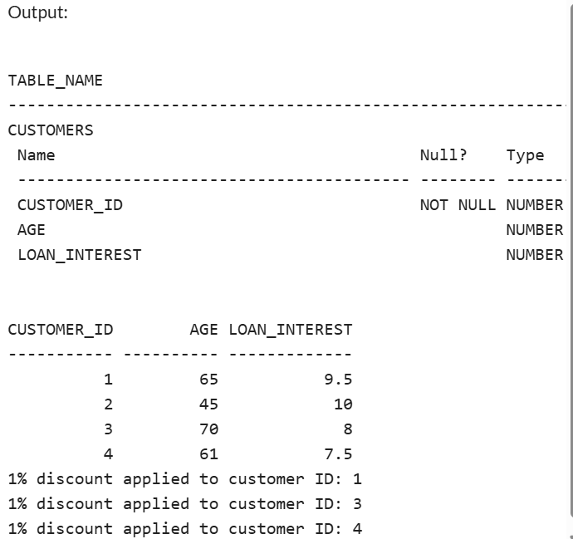

**Scenario 2:** A customer can be promoted to VIP status based on their balance.

* + **Question:** Write a PL/SQL block that iterates through all customers and sets a flag IsVIP to TRUE for those with a balance over $10,000.

**Program:**

CREATE TABLE CUSTOMERS (

CUSTOMER_ID NUMBER PRIMARY KEY,

BALANCE NUMBER(10, 2),

ISVIP VARCHAR2(5) DEFAULT 'FALSE'

);

INSERT INTO CUSTOMERS (CUSTOMER_ID, BALANCE) VALUES (1, 9500);

INSERT INTO CUSTOMERS (CUSTOMER_ID, BALANCE) VALUES (2, 15000);

INSERT INTO CUSTOMERS (CUSTOMER_ID, BALANCE) VALUES (3, 3000);

INSERT INTO CUSTOMERS (CUSTOMER_ID, BALANCE) VALUES (4, 25000);

INSERT INTO CUSTOMERS (CUSTOMER_ID, BALANCE) VALUES (5, 10500);

COMMIT;

SET SERVEROUTPUT ON;

BEGIN

FOR cust IN (SELECT CUSTOMER_ID, BALANCE FROM CUSTOMERS) LOOP

IF cust.BALANCE > 10000 THEN

UPDATE CUSTOMERS

SET ISVIP = 'TRUE'

WHERE CUSTOMER_ID = cust.CUSTOMER_ID;

ELSE

UPDATE CUSTOMERS

SET ISVIP = 'FALSE'

WHERE CUSTOMER_ID = cust.CUSTOMER_ID;

END IF;

END LOOP;

COMMIT;

DBMS_OUTPUT.PUT_LINE('VIP flags updated successfully.');

END;

/

SELECT CUSTOMER_ID, BALANCE, ISVIP FROM CUSTOMERS;

**OUTPUT:**

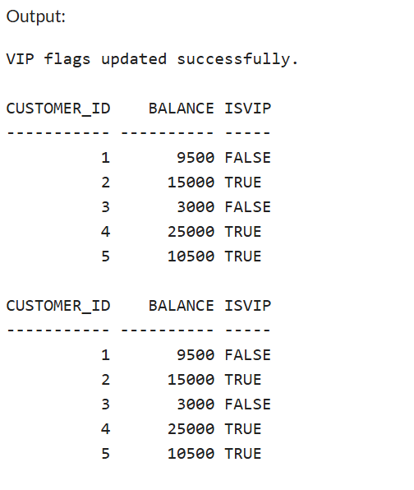

**Scenario 3:** The bank wants to send reminders to customers whose loans are due within the next 30 days.

* + **Question:** Write a PL/SQL block that fetches all loans due in the next 30 days and prints a reminder message for each customer.

Program:

SET SERVEROUTPUT ON;

SET DEFINE OFF;

-- Create the table

CREATE TABLE LOANS (

LOAN_ID NUMBER PRIMARY KEY,

CUSTOMER_ID NUMBER,

DUE_DATE DATE,

AMOUNT NUMBER(10, 2)

);

-- Insert sample data

INSERT INTO LOANS VALUES (1, 101, TO_DATE('2025-07-10', 'YYYY-MM-DD'), 5000);

INSERT INTO LOANS VALUES (2, 102, TO_DATE('2025-08-15', 'YYYY-MM-DD'), 7000);

INSERT INTO LOANS VALUES (3, 103, TO_DATE('2025-07-05', 'YYYY-MM-DD'), 8000);

INSERT INTO LOANS VALUES (4, 104, TO_DATE('2025-06-20', 'YYYY-MM-DD'), 6000);

COMMIT;

SELECT * FROM LOANS;

-- PL/SQL block to send reminders

BEGIN

FOR loan_rec IN (

SELECT LOAN_ID, CUSTOMER_ID, DUE_DATE, AMOUNT

FROM LOANS

WHERE DUE_DATE BETWEEN SYSDATE AND SYSDATE + 30

) LOOP

DBMS_OUTPUT.PUT_LINE(

'Reminder: Customer ' || loan_rec.CUSTOMER_ID ||

', your loan ID ' || loan_rec.LOAN_ID ||

' of amount $' || loan_rec.AMOUNT ||

' is due on ' || TO_CHAR(loan_rec.DUE_DATE, 'DD-Mon-YYYY')

);

END LOOP;

END;

/

**OUTPUT:**

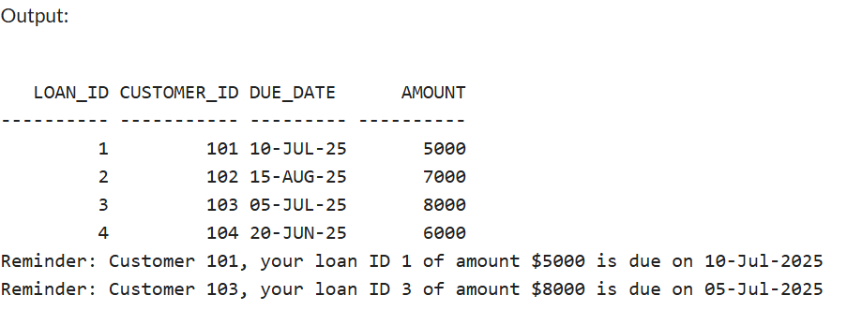

**Exercise 3: Stored Procedures**

**Scenario 1:** The bank needs to process monthly interest for all savings accounts.

* + **Question:** Write a stored procedure **ProcessMonthlyInterest** that calculates and updates the balance of all savings accounts by applying an interest rate of 1% to the current balance.

PROGRAM:

-- Drop tables first if re-running

BEGIN

EXECUTE IMMEDIATE 'DROP TABLE Transactions';

EXECUTE IMMEDIATE 'DROP TABLE Accounts';

EXECUTE IMMEDIATE 'DROP TABLE Loans';

EXECUTE IMMEDIATE 'DROP TABLE Employees';

EXECUTE IMMEDIATE 'DROP TABLE Customers';

EXCEPTION

WHEN OTHERS THEN NULL;

END;

/

-- Customers table

CREATE TABLE Customers (

CustomerID NUMBER PRIMARY KEY,

Name VARCHAR2(100),

DOB DATE,

Balance NUMBER,

LastModified DATE

);

-- Accounts table

CREATE TABLE Accounts (

AccountID NUMBER PRIMARY KEY,

CustomerID NUMBER,

AccountType VARCHAR2(20),

Balance NUMBER,

LastModified DATE,

FOREIGN KEY (CustomerID) REFERENCES Customers(CustomerID)

);

-- Transactions table

CREATE TABLE Transactions (

TransactionID NUMBER PRIMARY KEY,

AccountID NUMBER,

TransactionDate DATE,

Amount NUMBER,

TransactionType VARCHAR2(10),

FOREIGN KEY (AccountID) REFERENCES Accounts(AccountID)

);

-- Loans table

CREATE TABLE Loans (

LoanID NUMBER PRIMARY KEY,

CustomerID NUMBER,

LoanAmount NUMBER,

InterestRate NUMBER,

StartDate DATE,

EndDate DATE,

FOREIGN KEY (CustomerID) REFERENCES Customers(CustomerID)

);

-- Employees table

CREATE TABLE Employees (

EmployeeID NUMBER PRIMARY KEY,

Name VARCHAR2(100),

Position VARCHAR2(50),

Salary NUMBER,

Department VARCHAR2(50),

HireDate DATE

);

-- Sample Data Insertion

-- Customers

INSERT INTO Customers VALUES (1, 'John Doe', TO_DATE('1985-05-15', 'YYYY-MM-DD'), 1000, SYSDATE);

INSERT INTO Customers VALUES (2, 'Jane Smith', TO_DATE('1990-07-20', 'YYYY-MM-DD'), 1500, SYSDATE);

-- Accounts

INSERT INTO Accounts VALUES (1, 1, 'Savings', 1000, SYSDATE);

INSERT INTO Accounts VALUES (2, 2, 'Checking', 1500, SYSDATE);

-- Transactions

INSERT INTO Transactions VALUES (1, 1, SYSDATE, 200, 'Deposit');

INSERT INTO Transactions VALUES (2, 2, SYSDATE, 300, 'Withdrawal');

-- Loans

INSERT INTO Loans VALUES (1, 1, 5000, 5, SYSDATE, ADD_MONTHS(SYSDATE, 60));

-- Employees

INSERT INTO Employees VALUES (1, 'Alice Johnson', 'Manager', 70000, 'HR', TO_DATE('2015-06-15', 'YYYY-MM-DD'));

INSERT INTO Employees VALUES (2, 'Bob Brown', 'Developer', 60000, 'IT', TO_DATE('2017-03-20', 'YYYY-MM-DD'));

COMMIT;

-- Procedure: ProcessMonthlyInterest

CREATE OR REPLACE PROCEDURE ProcessMonthlyInterest

IS

BEGIN

UPDATE Accounts

SET Balance = Balance + (Balance * 0.01),

LastModified = SYSDATE

WHERE AccountType = 'Savings';

COMMIT;

DBMS_OUTPUT.PUT_LINE('Monthly interest applied to all savings accounts.');

END;

/

-- Enable DBMS output

SET SERVEROUTPUT ON;

-- Execute the procedure

EXEC ProcessMonthlyInterest;

-- Check updated balances

SELECT * FROM Accounts;

OUTPUT:

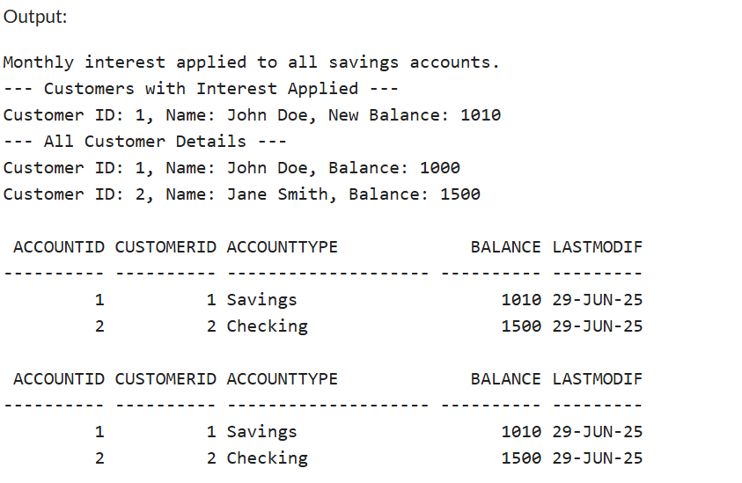

**Scenario 2:** The bank wants to implement a bonus scheme for employees based on their performance.

* + **Question:** Write a stored procedure **UpdateEmployeeBonus** that updates the salary of employees in a given department by adding a bonus percentage passed as a parameter.

**PROGRAM:**

-- Drop tables first if re-running

BEGIN

EXECUTE IMMEDIATE 'DROP TABLE Transactions';

EXECUTE IMMEDIATE 'DROP TABLE Accounts';

EXECUTE IMMEDIATE 'DROP TABLE Loans';

EXECUTE IMMEDIATE 'DROP TABLE Employees';

EXECUTE IMMEDIATE 'DROP TABLE Customers';

EXCEPTION

WHEN OTHERS THEN NULL;

END;

/

-- Customers table

CREATE TABLE Customers (

CustomerID NUMBER PRIMARY KEY,

Name VARCHAR2(100),

DOB DATE,

Balance NUMBER,

LastModified DATE

);

-- Accounts table

CREATE TABLE Accounts (

AccountID NUMBER PRIMARY KEY,

CustomerID NUMBER,

AccountType VARCHAR2(20),

Balance NUMBER,

LastModified DATE,

FOREIGN KEY (CustomerID) REFERENCES Customers(CustomerID)

);

-- Transactions table

CREATE TABLE Transactions (

TransactionID NUMBER PRIMARY KEY,

AccountID NUMBER,

TransactionDate DATE,

Amount NUMBER,

TransactionType VARCHAR2(10),

FOREIGN KEY (AccountID) REFERENCES Accounts(AccountID)

);

-- Loans table

CREATE TABLE Loans (

LoanID NUMBER PRIMARY KEY,

CustomerID NUMBER,

LoanAmount NUMBER,

InterestRate NUMBER,

StartDate DATE,

EndDate DATE,

FOREIGN KEY (CustomerID) REFERENCES Customers(CustomerID)

);

-- Employees table

CREATE TABLE Employees (

EmployeeID NUMBER PRIMARY KEY,

Name VARCHAR2(100),

Position VARCHAR2(50),

Salary NUMBER,

Department VARCHAR2(50),

HireDate DATE

);

-- Sample Data Insertion

-- Customers

INSERT INTO Customers VALUES (1, 'John Doe', TO_DATE('1985-05-15', 'YYYY-MM-DD'), 1000, SYSDATE);

INSERT INTO Customers VALUES (2, 'Jane Smith', TO_DATE('1990-07-20', 'YYYY-MM-DD'), 1500, SYSDATE);

-- Accounts

INSERT INTO Accounts VALUES (1, 1, 'Savings', 1000, SYSDATE);

INSERT INTO Accounts VALUES (2, 2, 'Checking', 1500, SYSDATE);

-- Transactions

INSERT INTO Transactions VALUES (1, 1, SYSDATE, 200, 'Deposit');

INSERT INTO Transactions VALUES (2, 2, SYSDATE, 300, 'Withdrawal');

-- Loans

INSERT INTO Loans VALUES (1, 1, 5000, 5, SYSDATE, ADD_MONTHS(SYSDATE, 60));

-- Employees

INSERT INTO Employees VALUES (1, 'Alice Johnson', 'Manager', 70000, 'HR', TO_DATE('2015-06-15', 'YYYY-MM-DD'));

INSERT INTO Employees VALUES (2, 'Bob Brown', 'Developer', 60000, 'IT', TO_DATE('2017-03-20', 'YYYY-MM-DD'));

COMMIT;

-- Procedure: ProcessMonthlyInterest

CREATE OR REPLACE PROCEDURE ProcessMonthlyInterest

IS

BEGIN

UPDATE Accounts

SET Balance = Balance + (Balance * 0.01),

LastModified = SYSDATE

WHERE AccountType = 'Savings';

COMMIT;

DBMS_OUTPUT.PUT_LINE('Monthly interest applied to all savings accounts.');

DBMS_OUTPUT.PUT_LINE('--- Customers with Interest Applied ---');

FOR rec IN (

SELECT c.CustomerID, c.Name, a.Balance

FROM Customers c

JOIN Accounts a ON c.CustomerID = a.CustomerID

WHERE a.AccountType = 'Savings'

) LOOP

DBMS_OUTPUT.PUT_LINE('Customer ID: ' || rec.CustomerID || ', Name: ' || rec.Name || ', New Balance: ' || rec.Balance);

END LOOP;

DBMS_OUTPUT.PUT_LINE('--- All Customer Details ---');

FOR cust IN (

SELECT * FROM Customers

) LOOP

DBMS_OUTPUT.PUT_LINE('Customer ID: ' || cust.CustomerID || ', Name: ' || cust.Name || ', Balance: ' || cust.Balance);

END LOOP;

END;

/

-- Procedure: UpdateEmployeeBonus

CREATE OR REPLACE PROCEDURE UpdateEmployeeBonus (

p_department IN VARCHAR2,

p_bonus_percent IN NUMBER

)

IS

BEGIN

UPDATE Employees

SET Salary = Salary + (Salary * p_bonus_percent / 100)

WHERE Department = p_department;

COMMIT;

DBMS_OUTPUT.PUT_LINE('Bonus of ' || p_bonus_percent || '% applied to employees in department: ' || p_department);

DBMS_OUTPUT.PUT_LINE('--- Updated Employee Details ---');

FOR emp IN (

SELECT * FROM Employees WHERE Department = p_department

) LOOP

DBMS_OUTPUT.PUT_LINE('Employee ID: ' || emp.EmployeeID || ', Name: ' || emp.Name || ', New Salary: ' || emp.Salary);

END LOOP;

END;

/

-- Enable DBMS output

SET SERVEROUTPUT ON;

-- Execute the procedures

EXEC ProcessMonthlyInterest;

EXEC UpdateEmployeeBonus('IT', 10);

-- Check updated balances and salaries

SELECT * FROM Accounts;

SELECT * FROM Employees;

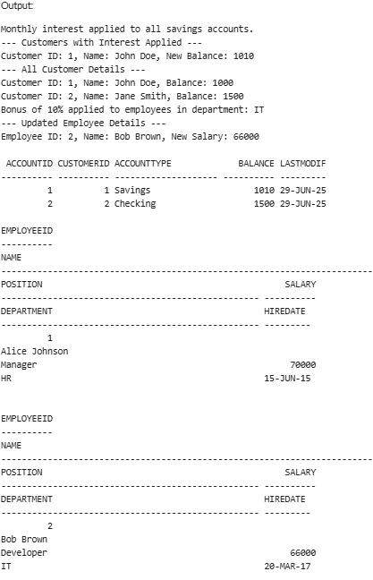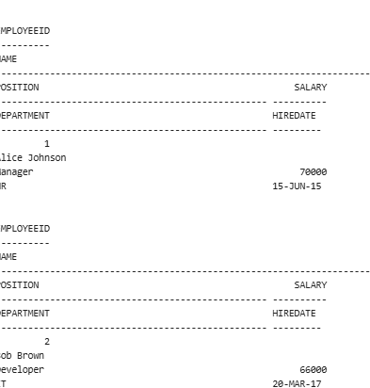

**Scenario 3:** Customers should be able to transfer funds between their accounts.

* + **Question:** Write a stored procedure **TransferFunds** that transfers a specified amount from one account to another, checking that the source account has sufficient balance before making the transfer.

**PRogram:**

-- Drop tables first if re-running

BEGIN

EXECUTE IMMEDIATE 'DROP TABLE Transactions';

EXECUTE IMMEDIATE 'DROP TABLE Accounts';

EXECUTE IMMEDIATE 'DROP TABLE Loans';

EXECUTE IMMEDIATE 'DROP TABLE Employees';

EXECUTE IMMEDIATE 'DROP TABLE Customers';

EXCEPTION

WHEN OTHERS THEN NULL;

END;

/

-- Customers table

CREATE TABLE Customers (

CustomerID NUMBER PRIMARY KEY,

Name VARCHAR2(100),

DOB DATE,

Balance NUMBER,

LastModified DATE

);

-- Accounts table

CREATE TABLE Accounts (

AccountID NUMBER PRIMARY KEY,

CustomerID NUMBER,

AccountType VARCHAR2(20),

Balance NUMBER,

LastModified DATE,

FOREIGN KEY (CustomerID) REFERENCES Customers(CustomerID)

);

-- Transactions table

CREATE TABLE Transactions (

TransactionID NUMBER PRIMARY KEY,

AccountID NUMBER,

TransactionDate DATE,

Amount NUMBER,

TransactionType VARCHAR2(10),

FOREIGN KEY (AccountID) REFERENCES Accounts(AccountID)

);

-- Loans table

CREATE TABLE Loans (

LoanID NUMBER PRIMARY KEY,

CustomerID NUMBER,

LoanAmount NUMBER,

InterestRate NUMBER,

StartDate DATE,

EndDate DATE,

FOREIGN KEY (CustomerID) REFERENCES Customers(CustomerID)

);

-- Employees table

CREATE TABLE Employees (

EmployeeID NUMBER PRIMARY KEY,

Name VARCHAR2(100),

Position VARCHAR2(50),

Salary NUMBER,

Department VARCHAR2(50),

HireDate DATE

);

-- Sample Data Insertion

-- Customers

INSERT INTO Customers VALUES (1, 'John Doe', TO_DATE('1985-05-15', 'YYYY-MM-DD'), 1000, SYSDATE);

INSERT INTO Customers VALUES (2, 'Jane Smith', TO_DATE('1990-07-20', 'YYYY-MM-DD'), 1500, SYSDATE);

-- Accounts

INSERT INTO Accounts VALUES (1, 1, 'Savings', 1000, SYSDATE);

INSERT INTO Accounts VALUES (2, 2, 'Checking', 1500, SYSDATE);

-- Transactions

INSERT INTO Transactions VALUES (1, 1, SYSDATE, 200, 'Deposit');

INSERT INTO Transactions VALUES (2, 2, SYSDATE, 300, 'Withdrawal');

-- Loans

INSERT INTO Loans VALUES (1, 1, 5000, 5, SYSDATE, ADD_MONTHS(SYSDATE, 60));

-- Employees

INSERT INTO Employees VALUES (1, 'Alice Johnson', 'Manager', 70000, 'HR', TO_DATE('2015-06-15', 'YYYY-MM-DD'));

INSERT INTO Employees VALUES (2, 'Bob Brown', 'Developer', 60000, 'IT', TO_DATE('2017-03-20', 'YYYY-MM-DD'));

COMMIT;

-- Procedure: ProcessMonthlyInterest

CREATE OR REPLACE PROCEDURE ProcessMonthlyInterest

IS

BEGIN

UPDATE Accounts

SET Balance = Balance + (Balance * 0.01),

LastModified = SYSDATE

WHERE AccountType = 'Savings';

COMMIT;

DBMS_OUTPUT.PUT_LINE('Monthly interest applied to all savings accounts.');

DBMS_OUTPUT.PUT_LINE('--- Customers with Interest Applied ---');

FOR rec IN (

SELECT c.CustomerID, c.Name, a.Balance

FROM Customers c

JOIN Accounts a ON c.CustomerID = a.CustomerID

WHERE a.AccountType = 'Savings'

) LOOP

DBMS_OUTPUT.PUT_LINE('Customer ID: ' || rec.CustomerID || ', Name: ' || rec.Name || ', New Balance: ' || rec.Balance);

END LOOP;

DBMS_OUTPUT.PUT_LINE('--- All Customer Details ---');

FOR cust IN (

SELECT * FROM Customers

) LOOP

DBMS_OUTPUT.PUT_LINE('Customer ID: ' || cust.CustomerID || ', Name: ' || cust.Name || ', Balance: ' || cust.Balance);

END LOOP;

END;

/

-- Procedure: UpdateEmployeeBonus

CREATE OR REPLACE PROCEDURE UpdateEmployeeBonus (

p_department IN VARCHAR2,

p_bonus_percent IN NUMBER

)

IS

BEGIN

UPDATE Employees

SET Salary = Salary + (Salary * p_bonus_percent / 100)

WHERE Department = p_department;

COMMIT;

DBMS_OUTPUT.PUT_LINE('Bonus of ' || p_bonus_percent || '% applied to employees in department: ' || p_department);

DBMS_OUTPUT.PUT_LINE('--- Updated Employee Details ---');

FOR emp IN (

SELECT * FROM Employees WHERE Department = p_department

) LOOP

DBMS_OUTPUT.PUT_LINE('Employee ID: ' || emp.EmployeeID || ', Name: ' || emp.Name || ', New Salary: ' || emp.Salary);

END LOOP;

END;

/

-- Procedure: TransferFunds

CREATE OR REPLACE PROCEDURE TransferFunds (

p_from_account IN NUMBER,

p_to_account IN NUMBER,

p_amount IN NUMBER

)

IS

v_balance NUMBER;

BEGIN

SELECT Balance INTO v_balance FROM Accounts WHERE AccountID = p_from_account FOR UPDATE;

IF v_balance < p_amount THEN

RAISE_APPLICATION_ERROR(-20001, 'Insufficient funds in source account.');

END IF;

UPDATE Accounts

SET Balance = Balance - p_amount,

LastModified = SYSDATE

WHERE AccountID = p_from_account;

UPDATE Accounts

SET Balance = Balance + p_amount,

LastModified = SYSDATE

WHERE AccountID = p_to_account;

INSERT INTO Transactions (TransactionID, AccountID, TransactionDate, Amount, TransactionType)

VALUES (Transactions_seq.NEXTVAL, p_from_account, SYSDATE, p_amount, 'Transfer');

INSERT INTO Transactions (TransactionID, AccountID, TransactionDate, Amount, TransactionType)

VALUES (Transactions_seq.NEXTVAL, p_to_account, SYSDATE, p_amount, 'Receive');

COMMIT;

DBMS_OUTPUT.PUT_LINE('Transferred $' || p_amount || ' from account ' || p_from_account || ' to account ' || p_to_account);

END;

/

-- Enable DBMS output

SET SERVEROUTPUT ON;

-- Execute the procedures

EXEC ProcessMonthlyInterest;

EXEC UpdateEmployeeBonus('IT', 10);

EXEC TransferFunds(1, 2, 200);

-- Check updated balances and salaries

SELECT * FROM Accounts;

SELECT * FROM Employees;

SELECT * FROM Transactions;

OUTPUT

 